Team Members

Naman Rastogi (163050056)  
Vinay Teja Koona (163050054)  
Anbarsan (163050072)

Smart Greenhouse Controller

CS684 – 2016 Final Report

Introduction

The world is changing, and at this point we cannot tell is it for good or bad for us in the future, but the situation is definitely not good for greenery, plant, trees and forests and we definitely must do something otherwise we will not be able to save our planet. With the increasing pollution and global warming, the Greenhouses are the need of the hour.

But there lies the main problem, in today’s world, nobody has the time to manage a greenhouse, when they are not even able to manage between their professional and personal life. And there comes the need of a greenhouse controller. This will help a person not only controlling it remotely but efficiently, letting them focus on their professional and personal life, and not worrying about the greenhouse, so they don’t have to waste 5-6 hours a day managing the greenhouse and be present there physically, managing the temperature, humidity, soil moisture, etc.

Problem Statement

The aim of this project is to build a Smart Greenhouse System, which is an IOT (Internet Of Things) based system that can control Greenhouse using Android App remotely according to the need of the user.

The system must be able to monitor and control the greenhouse according to the set points set by the user on temperature and soil moisture. Also, it should be able to monitor and control internal artificial light, for instance light bulbs, tube-lights, etc. and adjusts according to the natural light coming in. If the natural light coming in is enough for the plantation inside the greenhouse, then the lights should be off and if not then they should turn on automatically.

Requirements

1. **Functional Requirements**
   1. Live data of temperature and humidity of green house should be measured and displayed in the android app
   2. Fan, Light Bulb, Water Motor and other LEDs should be turned on/off from android app
   3. The devices should be turned on/off based on timers set by the user
   4. The artificial lightning inside the green house should be turned on/off based on surrounding light as measure by LDR sensor
   5. The temperature and humidity of the green house should be maintained at the user given set points from android app by turning devices (light, fan, water motor etc.) on/off appropriately.
   6. Water motor should be turned on only for two seconds at a time to limit the increase in soil moisture and maintain it less than or equal to the given set point.
   7. Data transfer between android app and server should be through internet so that user can control the green house from anywhere.
2. **Non Functional requirements**
   1. Interface of android app should be user friendly and intuitive
   2. Monitoring and controlling of temperature and humidity should be maintain the values within 2% of given set points
   3. Android app should work with limited mobile data usage.
   4. It should be easy to remove devices or add new devices to the system (change in hardware) and in android app (change in software)
3. **Hardware Requirements**
   1. Microcontroller (Tiva C Series TM4C123G)
   2. Electric Fan
   3. Light Bulbs
   4. Heater / Blower
   5. Water Pump
   6. Temperature Sensor (LM35)
   7. Soil Moisture Sensor (YL69)
   8. Sensor to measure intensity of light (LDR)
4. **Software Requirements**
   1. Code Composer Studio / Energia
   2. Apache, MySQL Server (WAMP / XAMPP / LAMP)
   3. Python 3

System Design

The system can be visually represented by using the following diagram. It contains a Microcontroller controlling the actuators as per the input from the various sensors connected to it. The microcontroller is always in continuous synchronization with the server, that is the PC.

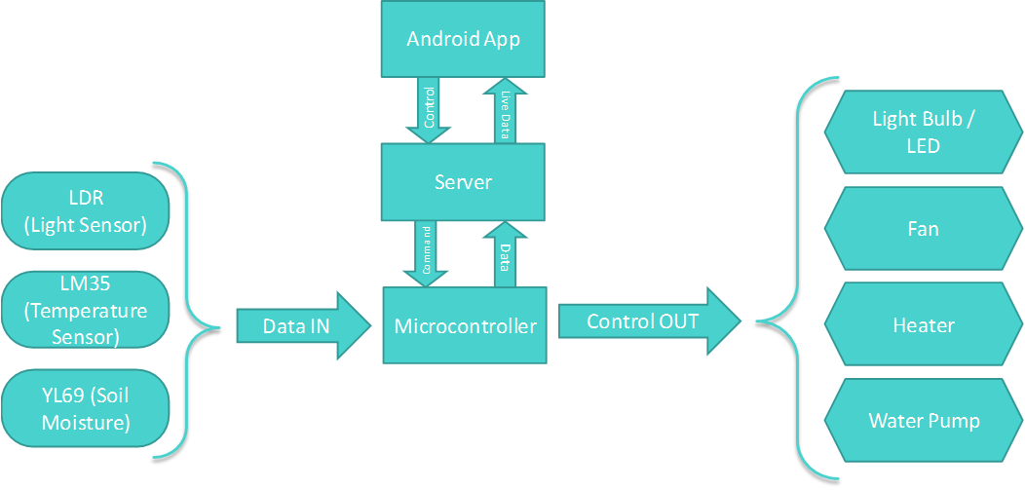

The android app shows the end user the live temperature and soil moisture. The app also enables the end user to set some profiles to set certain parameters at a particular time, for example the user can sat the lights to turn on at 7PM, or can set so that the temperature ranges between 25 and 28 degrees Celsius only and does not go outside that range, and if it does then the microcontroller will automatically take certain actions to not let that happen. The android app gives commands to the server whenever the user needs and receives the Temperature and Soil moisture from the server at regular intervals, say 5s.

The working of the microcontroller is shown below with the help of a diagram. The microcontroller runs in a never ending loop, checking the server status, temperature range, soil moisture range and the light range every time inside the loop.

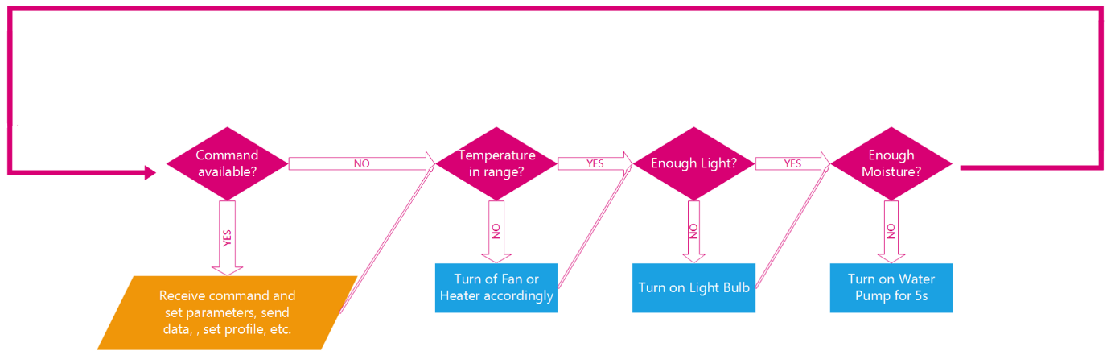

The microcontroller, as soon as it enters the loop, first receives the data from all the sensors and calculate the temperature in degrees Celsius, data from the Soil Moisture and data from LDR about the intensity of light inside the greenhouse.

Then it checks if there is any command available from the server or not, if there is then it receives the command and acts accordingly. If the commands tell it to send it the data from all the sensors, then it does that, if it tells it to set certain parameters to be met, then it receives those parameters and sets them. If the server tells it to turn on or off a particular device, then it does that.

Working of the System and Test Results

|  |  |
| --- | --- |
| **Feature** | **Test Plan** |
| Increase temperature to a set point | Light Bulb should turn on if current temperature is less than set point and turn off otherwise |
| Reduce temperature to a set point | Fan should turn on if current temperature is greater than set point and turn off otherwise |
| Read data from sensors continuously | Update serial data into database with current timestamp |
| Increase soil moisture to a set point | Water motor should turn on for two seconds at a time until soil moisture value is reached |
| Turn device on/off based on timer | Set an on-timer for after 1 minute and off-timer for after 2 minutes and device should turn on and turn off after respective time interval |

Discussion of the System

1. **Components of the project worked as per plan**
   1. Android App

The android app is the component which is in the hands of client or end user. It shows live feed from the server about the current temperatures and soil moisture, etc., it sends instant commands to turn on or off which device at a particular instant and it also enables the user to set profiles so that the microcontroller automatically maintains the current temperatures and soil moisture.

* 1. Online Server

The server is the heart of the system. It is the module of the system that acts as an intermediary between the client and the microcontroller. It maintains the timer commands sent by the user and then after the set time, it sends command to the microcontroller telling it what to do now.

* 1. Controlling devices interactively from app and automatically based on set points.

1. **Components added more than discussed in SRS**
   1. We made a complete API for serial communication of the server with the microcontroller, which made sending data and commands from the PHP to the microcontroller and receiving data from it very easy and error free.
2. **Changes made in plan from SRS:**
   1. Microcontroller used was Tiva C Series TM4C123G instead of initially planned CS3200
   2. Used serial communication of server and micro controller instead of through Wi-Fi

Future Work

The future work of this project would be:

1. The prototype consists of serial communication between the microcontroller and the server for communication between them, but we would like to have a wireless communication between them. For instance, they needed to be connected through the Wi-Fi.
2. This prototype consists of direct communication between the relay and electric AC fan and motor, but it is now the correct way as the due to some induction effect, the AC fans and motors does not work correctly, and thus requires some additional circuitry for a proper connection.
3. Along with the android app, it would be very nice to have a web interface as well to control the system, set parameters, get live feed, etc.

Conclusion

This kind of system are very feasible and within the reach of normal or average person. They provide huge flexibility for the user and supports wide range of plantation, the only thing needed to setup is the optimal temperature, humidity and soil moisture for the plants. This kind of system can also be changed by a little to get more functionality out of them and can be used in wide range of application, like

1. The system can be enlarged to a large scale to be used with a home or office or factory, consisting of 100s of lights, many fans, many appliances, machines etc.
2. The system can be used in hospitals, enabling the doctors to monitor the patients remotely, recommending medicines, etc.

References

1. <https://github.com/CS308-2016/HomeAutomation>
2. <https://drive.google.com/open?id=0B78_oTe9YEyjTmdid1g3NGVONXc>